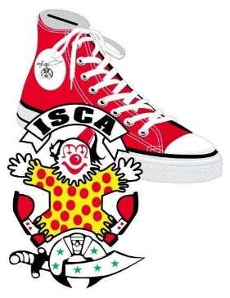
2019 ISCA MID-WINTER SESSION
Hosted by: Medinah Clowns
February 13-17, 2019
Medinah Shrine Center
550 Shriners Drive
Addison, IL 60101

Name:________________________________________ I will compete in:
Clown Name: __________________________________ White Face: _____
Ladies Name: __________________________________ Auguste: _____
Temple: ______________________________________ Auguste Lite: _____
Phone #: _____________________________________ Tramp: _____
Email: ________________________________________ Hobo: _____
Is this your first ISCA Mid-Winter? Yes / no Character: _____
Send Registration to: Senior: _____
Tracy “PEANUT” Burcham (cell # 630-310-1183) Paradeability _____
Medinah Shrine Clown Unit / ISCA 1 Man Skit _____
409 Collen Drive 2 Man Skit _____
Lombard, IL 60148 Group Skit _____
Face paint Cheek _____
Registration Fees: (no refunds after 2/1/19) Face Paint Full _____
Clown: = $150 $ _______ Single Balloon _____
Lady: = $125 $_______ Multiple Balloons _____
Children: = $75 per child X_____ = $_______ Powder Puff _____
Total: $_______ Fun Stuff: 2 man make up _____
Make check payable to: Medinah Shrine Clown Unit Group Make up _____
Let us know if you have any special dietary needs Kids Choice _____
- Registration includes Theme Party Dinner, Black Camel Luncheon and Banquet tickets.
- Call for extra meal tickets. Theme party $25, Black Camel $25, Banquet, $40
- All competition and Hospitality will be at the Medinah Shrine Center.
- Call the Hotel directly to make reservations under ISCA or Shrine Clowns: Rate is $99 per night. Phone number: 630-691-0500, Hilton Garden Inn, 551 N. Swift Rd., Addison IL 60101.
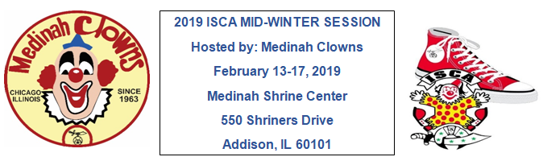
Page…2
Registration includes Theme Party Dinner, Black Camel Luncheon and Banquet tickets. Competition and Hospitality are included and will be at the Medinah Shrine Center.
Hotel: The Hilton Garden Inn, 551 N. Swift Rd, Addison, IL. The hotel is located just across the parking lot from the Medinah Shrine Center.
Competition and Hospitality: At the Medinah Shrine Center, 550 Shriners Drive, Addison, IL
Make up competition: We will have the usual ISCA Mid-Winter competitions. There is a new category, Auguste Lite. Please see the ISCA website for the rules on Auguste Lite.
Chicago Hospital Visit: Wednesday morning with a stop for hot dogs on the way back.
Theme Party: A Salute to the Troops. We will be sending care packages to our troops stationed overseas. Please bring the name of someone stationed overseas, so we can send them a package. Bring small items to put in the box and/or consider a donation toward postage.
Education: 16 educational classes are planned. See the ISCA website for details.
Fun Competitions:
Two Man make up. You put your make up on me, I put my make up on you, Find a partner.
Group Make up: This is a unit make up competition, we are stealing from the TSCA. Choose a member to make up. That person can’t help in any way, not even to lift an arm to help put on their shirt. Make him up, dress him and stand him up. First one up, completely dressed and made up wins.
Kids Choice: We have kids from DeMolay, Rainbow and Jobs Daughters coming to be judges. Each clown wishing to participate will draw a number for a table to work from. Rules; you must stay at your table, you may not interfere with another clown. No other rules. Entertain the kids however you wish. Balloons, face painting, magic, puppets, juggling…etc. You choose what to do. The kids will vote for the winner. Cash prize for the winner.

Any questions???? Contact John “JAY JAY” Joseph, ISCA, 1st VP
Cell # 847-483-4520, or email; jayjay360@hotmail.com.

